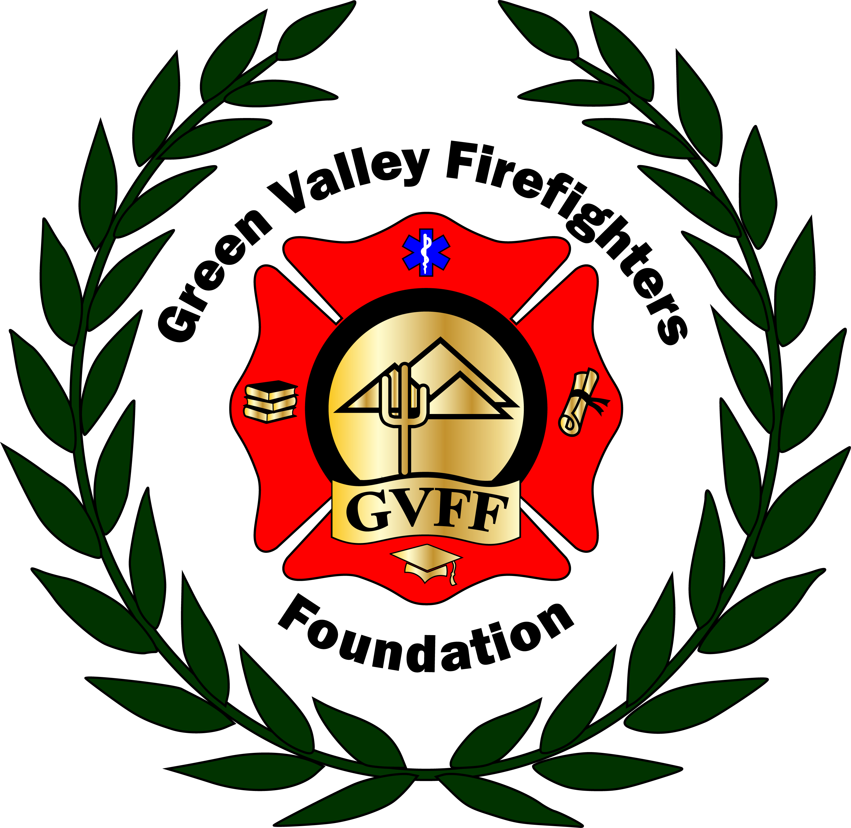
Green Valley Firefighters Foundation
1285 West Camino Encanto
Green Valley, Arizona 85622-8222
520/625.9400

The Green Valley Firefighters Foundation Board of Directors Meeting
HQ/Training Center
December 13, 2017, 5:00 P.M.
19th Hole

Board Meeting Minutes
- Call to Order – President Anthony Taylor called the meeting to order at 5:11 P.M. Present were Talia Carey, Anthony Taylor, and Sarah Nowell, Anathea Taylor, Selina Kubitskey, and Chuck Wunder.
- Approval of Minutes from November 27, 2017- Talia Carey presented the minutes from the November 27, 2017 meeting for approval. Anthony Taylor made a motion to approve the minutes. Talia Carey seconded the motion. All were in favor and the motion passed.
- Financial Report- None.
- New Business
- Pickleball: The pickleball website has 95 people registered so far, last year’s numbers were at 75. Anthony is having a meeting on 12-22 for logistics and such. Talia reminded him about the $25.00 Safeway card for concessions. He stated Chris Scheller will be handling the ordering of the medals, 20 gold, 20 silver and 20 bronze, plus the foil back stickers.
- Ball- The group had a discussion regarding Epi’s transition over to Miguel Venado. Anthony Taylor made a motion to purchase a $50.00 gift card to somewhere like ULTA, as well as flowers for Epi’s help over the years. Sarah Nowell seconded. Talia stated she would pick up the gifts and deliver tomorrow (12-14) and be reimbursed later, as it was Epi’s last day. We discussed the updated contract for the photo booth and the sponsorship for the photo sponsor from Swanson Plumbing. They also purchased the rest a table. Talia gave an update on her sponsorships that had already come in, such as Lovitt and Touche at $1500.00, Safeway at $1500.00, and those that she had reached out to already, such as Fry’s, which was denied, UCHC, Jim Click, The Marshall Foundation, Gadabout, AFLAC, Canoa Ranch & Freeport McMoran, as well as Gadabout & Wyndham for prizes/Giveaways. She stated Chris Scheller has submitted to Desert Diamond and Geico for Sponsorships. Anthony Taylor will work on Nova, John Rinehart with Edward Jones, Ace/True Value. Selina Kubitskey gave an update regarding the Rancho HOA, that contact is no longer in place but she will still reach out to them. Anthony will reach out to Continental Plaza regarding signage. Anthony Taylor advised the red carpet has been addressed and they are checking on availability. Katina Murphy is available, and we need to budget a gift card and her tickets. Sarah Nowell will get a few quotes on the carnations, and works on the car club to see if any other cars are available. She also said she could help with Nova, as she used to work there.
- Next Meeting Date: January 4 @ 4:30 at HQ.

- Adjourn - There being no further business, the meeting was adjourned at 5:56 P.M.

