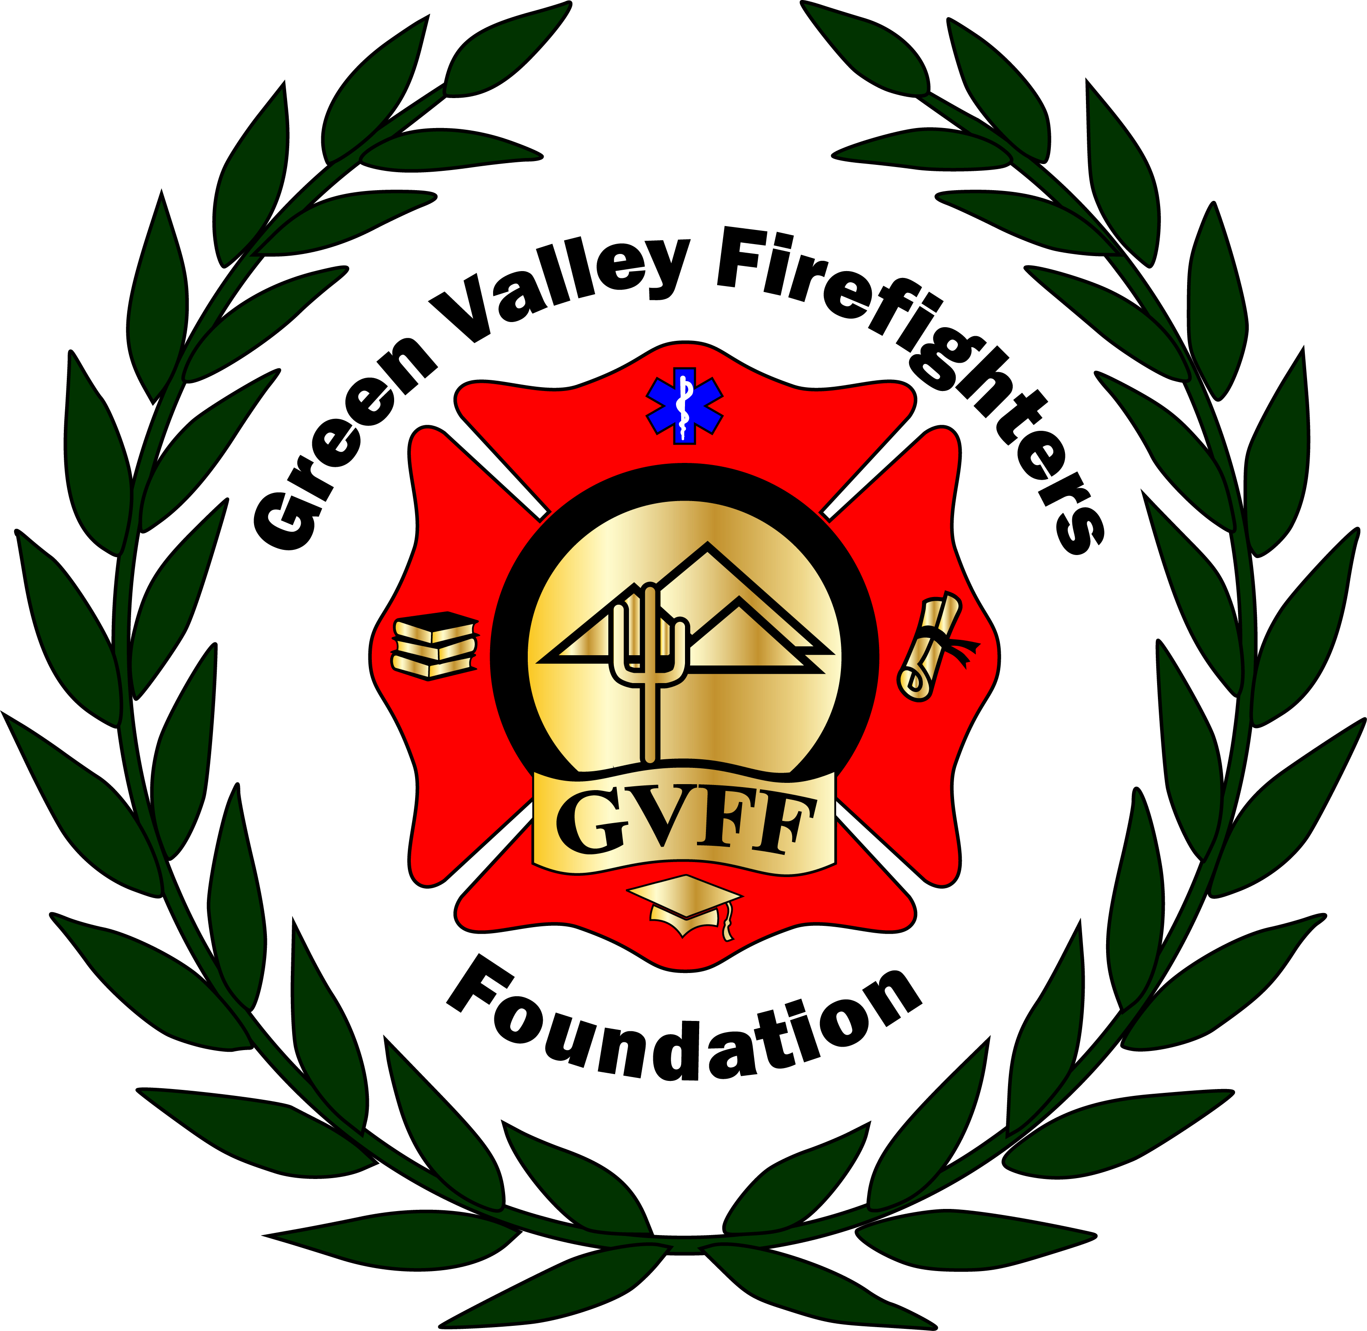
Green Valley Firefighters Foundation
1285 West Camino Encanto
Green Valley, Arizona 85622-8222
520/625.9400

NOTICE OF MEETING OF
THE GREEN VALLEY FIREFIGHTERS FOUNDATION BOARD
October 4, 2018 4:30 P.M.
The Springs/ GVR

AGENDA
- Call to Order – Vice President Chris Scheller
- Approval of Minutes from August 23 & September 13, 2018 – Secretary Talia Carey
- Financial Report – Chief Wunder
- Old Business – None
- New Business –
- Discussion and Possible Action re: Scholarship Applications- We need to vote on three scholarship applications received for this past fiscal quarter on the website. (Mike Downes Jr, medic Class, Austin Roush- State Fire School, and TJ Lundgren, for his Degree.)
- Discussion and Possible Action re: Ball Location Change- Chris Scheller & Kristi Kosiorowski- (venue pros & cons)
- Discussion and Possible action re Pickleball tournament Date of January 19 & 20 date change- group discussion/ Chief Wunder-
- Mardi Gras 2019! – Discussion and possible action re EMCEE Scott Lehman for the ball. Other Ball topics also will be discussed. Discussion and Poss action regarding the band (The rezonators). Sponsorship levels (adjustments?), website feature- ect).

- Set Next Meeting Date –

- Adjourn-

