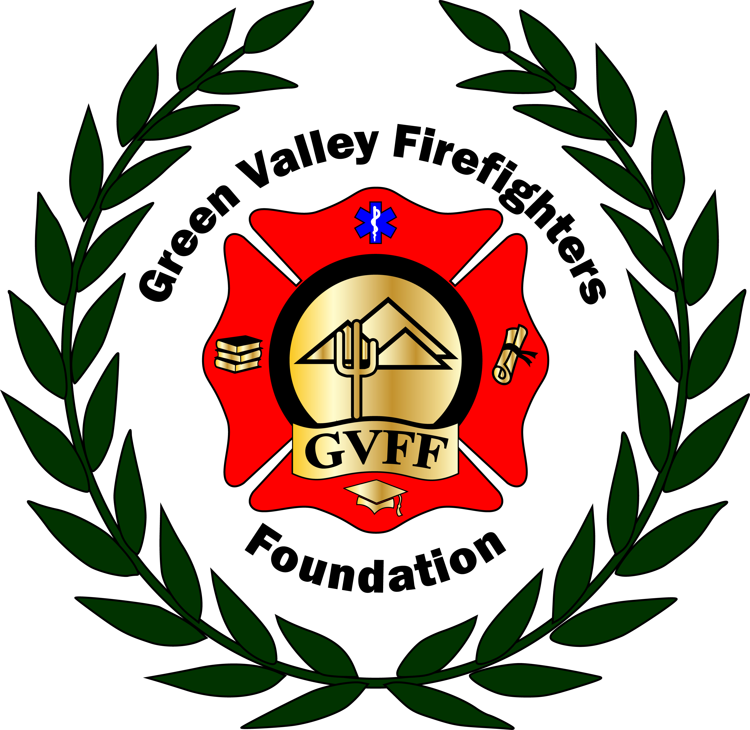
Green Valley Firefighters Foundation
1285 West Camino Encanto
Green Valley, Arizona 85622-8222
520/625.9400

NOTICE OF MEETING OF
THE GREEN VALLEY FIREFIGHTERS FOUNDATION BOARD
July 12,2018 4:30 P.M
HQ/1285 W. Camino Encanto

AGENDA
- Call to Order – President Anthony Taylor
- Approval of Minutes from June 27, 2018 – Secretary Talia Carey
- Financial Report – None
- Old Business –
- Follow Up on Reimbursement Request- Did anyone applicant know?
- Website- Its almost up and should be live tomorrow.
- Insurance Quote- Meeting/Conference call next week to finalize.
- Off Duty Shirt design additional Quotes- Someone needs to take this on. CAN wait until after mid-year event.
- By Law Review- Please get this reviewed and save changes until AFTER mid-year event.
- QC Pickleball Thank you- Tabled until after mid-year event.
- New Business –
- Scholarships- Chris Scheller wanted to discuss opening another application period for backdated classed. Potential application date range should be from last closing period to this one. Acceptable courses or reimbursements?
- Mid-Year Event-. Saturday August 11, 2018 6-9. Show starts at 6:30. 1 hour 45 minutes, with a 15-minute intermission. QC is $750.00 Band is $2200. Tickets are $27.00, covers the Stripe service fee of 2.9% plus .30 cent flat fee. Lots to discuss about the event.
- Sizing Shirts/ Order-

- Set Next Meeting Date –

- Adjourn-

