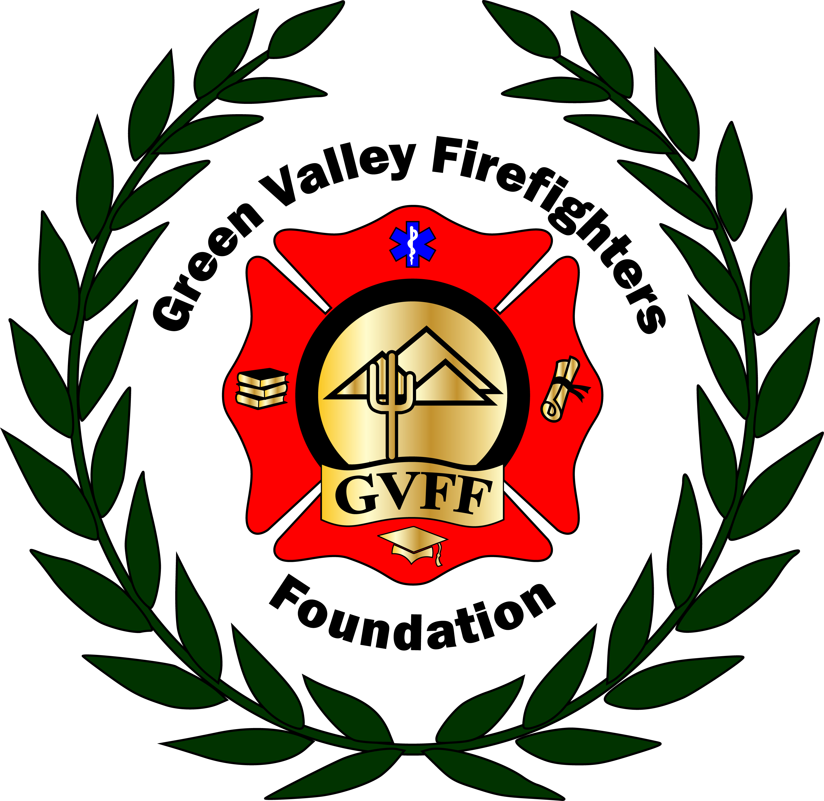
Green Valley Firefighters Foundation
1285 West Camino Encanto
Green Valley, Arizona 85622-8222
520/625.9400

NOTICE OF MEETING OF
THE GREEN VALLEY FIREFIGHTERS FOUNDATION BOARD
June 27,2018 4:30 P.M
HQ/1285 W. Camino Encanto

AGENDA
- Call to Order – President Anthony Taylor – Called to order at 4:40. Present were Scheller, Barter, Nowell, Kubitskey, Kosiorowski, Kelley, Carey, Taylors.
- Approval of Minutes from May 15, 2018 – Secretary Talia Carey, Scheller, Barter, . All in Favor.
- Financial Report – Chief Wunder
- Old Business – None.
- New Business –
- By-law Review-
- Insurance Quotes Review–
- Polos for Board-
- Off Duty T shirts for Sale-
- Dates from Chief Wunder /Fanning for Mid-Year event
- QC PB Thank you –
- Ball Theme for this Year
- Dougall’s reimbursement Request
- Website -
- Credit Card (approved in January 4, 2018 minutes)
- Disney Application.

- Set Next Meeting Date –

- Adjourn-

