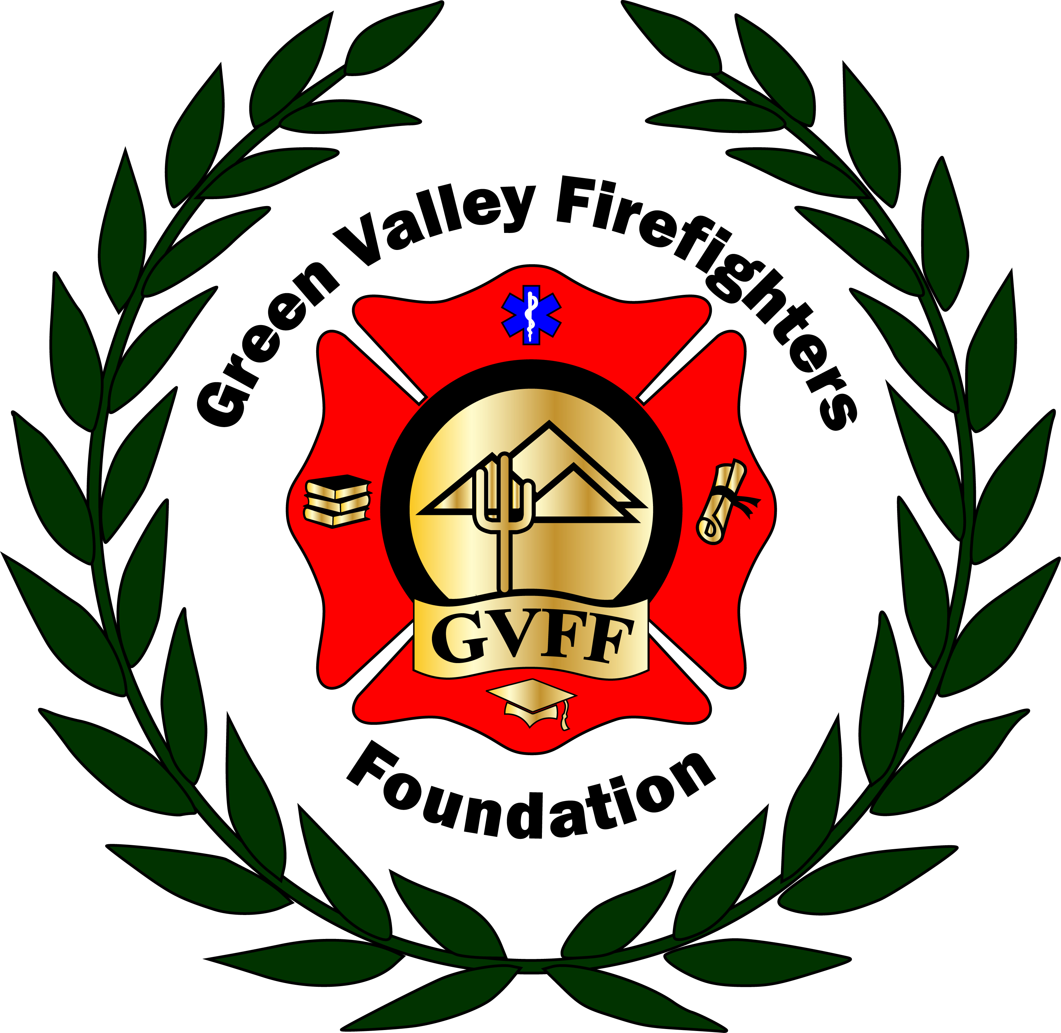
Green Valley Firefighters Foundation
1285 West Camino Encanto
Green Valley, Arizona 85622-8222
520/625.9400

NOTICE OF MEETING OF
THE GREEN VALLEY FIREFIGHTERS FOUNDATION BOARD
May 14,2018
HQ/1285 W. Camino Encanto

AGENDA
- Call to Order – President Anthony Taylor
- Approval of Minutes from April 4, 2018 – Secretary Talia Carey
- Financial Report – Chief Wunder
- Old Business – Follow up with Chief Wunder on the Articles of Incorporation.
- New Business –
- Website for Foundation- We need to review the contract proposal and vote whether we want to use Ravens Eye Design/Chad Bush for the website Build. He has already secured the domain WWW.GVFF.ORG for us.
- Insurance for GVFF – Conference call Thursday with L&T @ 3PM
- Firehouse Auction Dinner- May 20, 2018- Sunday Night- A Shift. Date is confirmed. We need to get the shopping done. It was confirmed that 8 people will be in attendance, and the start time is 5pm. Volunteers should be there no later than 3:30 at 155.
- Polo Shirts for Board, T shirts for Sale. Chris said he can work with McKinney who has a friend that is a graphic designer. Has started with Local Co as well.
E. Mid-Year event. Talia has reached out to Daniel at QC twice already to try and get date availability with no luck yet. He said he would get back to her on April 17. She reached out again on 5/3/18 and got dates of Sept: Friday the 7th or Saturday 8^{th,} October: Saturday the 6th or Saturday the 13^{th:} November: Sunday the 11th. Chief Wunder will reach out to Fanning re availability.
F. Thank you for QC Pickleball club. Sign/Bench?

- Set Next Meeting Date –

- Adjourn-

