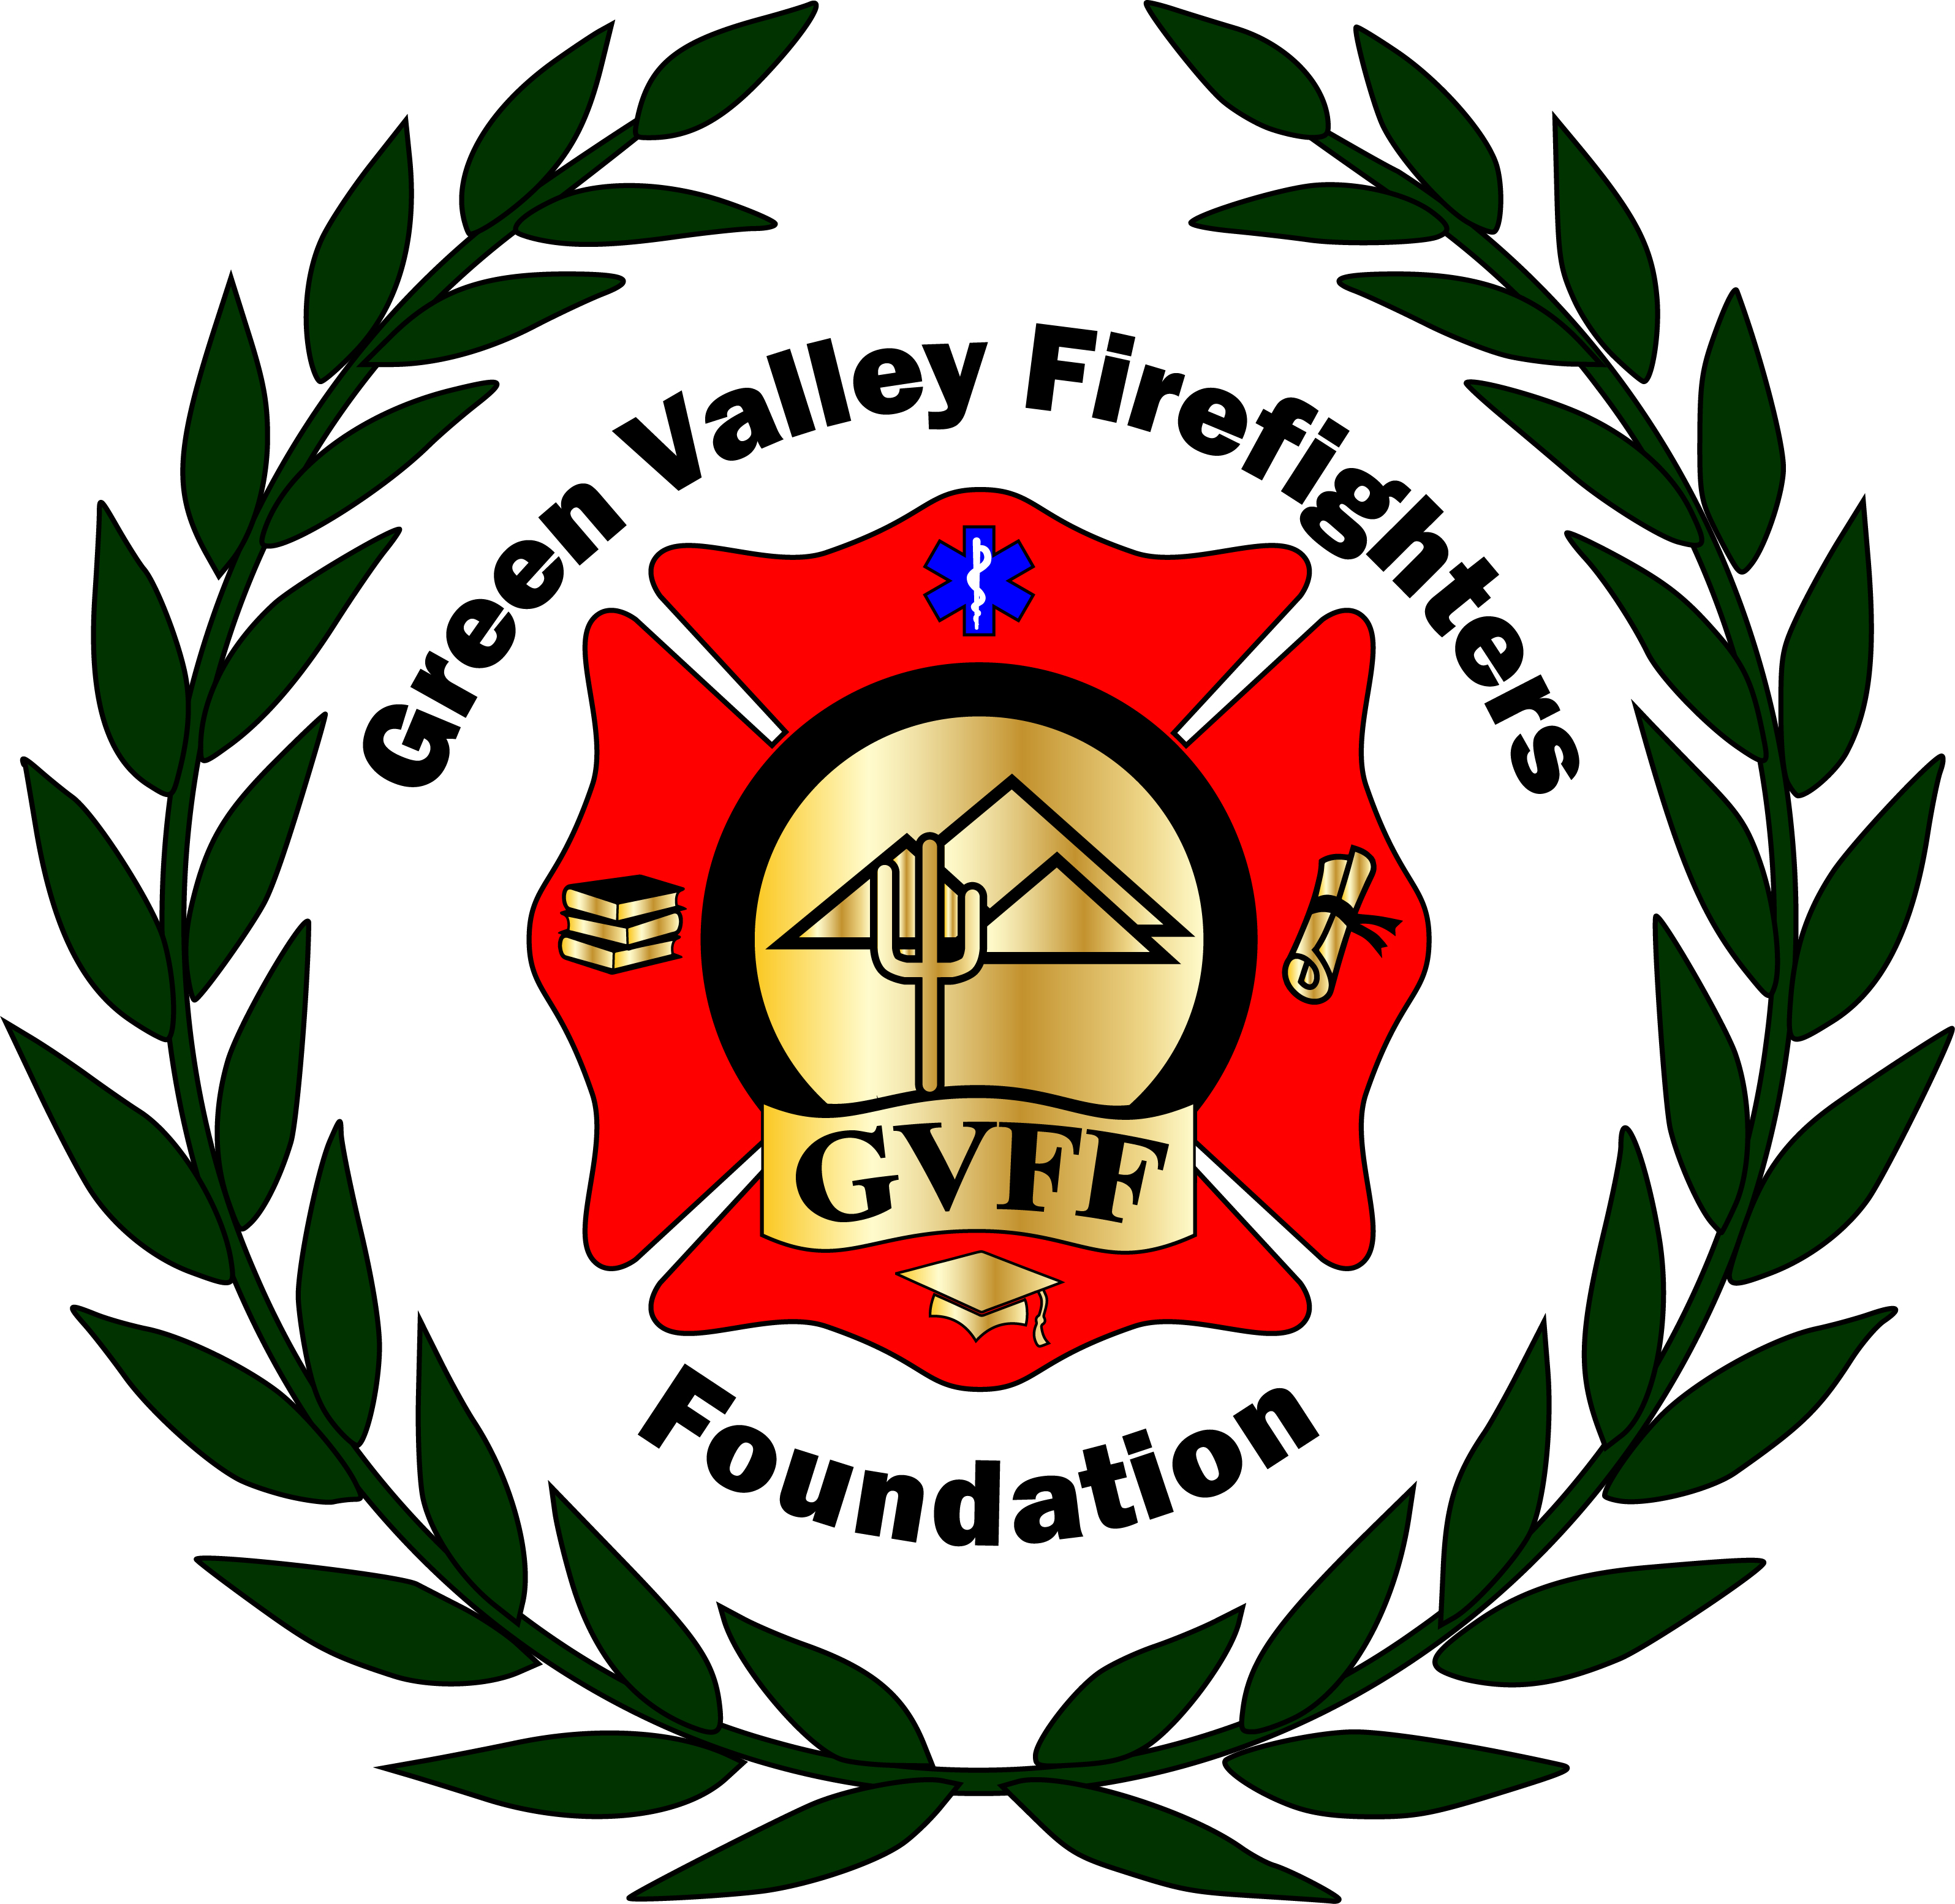
Green Valley Firefighters Foundation
1285 West Camino Encanto
Green Valley, Arizona 85622-8222
520/625.9400

NOTICE OF MEETING OF
THE GREEN VALLEY FIREFIGHTERS FOUNDATION BOARD
April 4,2018
1285 W. Camino Encanto

AGENDA
- Call to Order – President Anthony Taylor
- Approval of Minutes from March 8, 2018 – Secretary Talia Carey
- Financial Report – Chief Wunder – Credit Card Fees Reimbursement to the District $265.07.
- Old Business – None
- New Business –
- Board Positions – Per our by-laws they need to be one-year terms. Terms shall be from January to December. (Section 4:03 of our bylaws. Let’s read this section at meeting.) Chief Wunder has been in his Treasurer position since the inception. Taylor, Scheller and Carey since 5/4/17.
- Website for Foundation- (Talia has one under construction at WIX.COM- free hosting site, it is NOT published yet…)
- Ball Date for 2019- Reserved for March 30, 2019 currently.
- Firehouse Auction Dinner- May 20, 2018- Sunday Night- A Shift is their first choice.

- Set Next Meeting Date –

- Adjourn-

