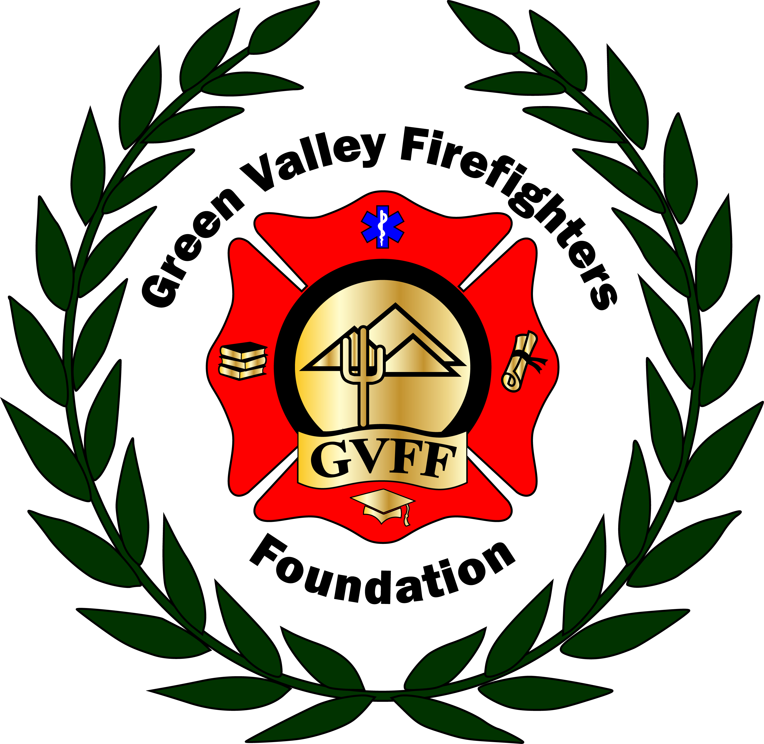
Green Valley Firefighters Foundation
1285 West Camino Encanto
Green Valley, Arizona 85622-8222
520/625.9400

NOTICE OF MEETING OF
THE GREEN VALLEY FIREFIGHTERS FOUNDATION BOARD
December 13, 2018 4:30 P.M.
GVFD HQ/1285 W. Camino Encanto

AGENDA
- Call to Order –President Anthony Taylor
- Approval of Minutes from October 4 & October 16, 2018 – Secretary Talia Carey (In draft form- Talia will go over notes as refresher)
- Financial Report – Chief Wunder
- Director Round Table Update – Board of Directors
- Old Business – None
- New Business –
- Discussion and Possible Action re: Scholarship Applications- We have received one application thus far for this period. Our fiscal quarter will close Dec 31. We need to vote on this prior to our next meeting, unless we wait until after January.)
- Open Discussion and Possible Action re: Jan 19/20, 2019 Pickleball Tournament- GVFF
- Open Discussion and Possible action re: March 30, 2019 Mardi Gras Masquerade- GVFF

- Set Next Meeting Date –

- Adjourn-

