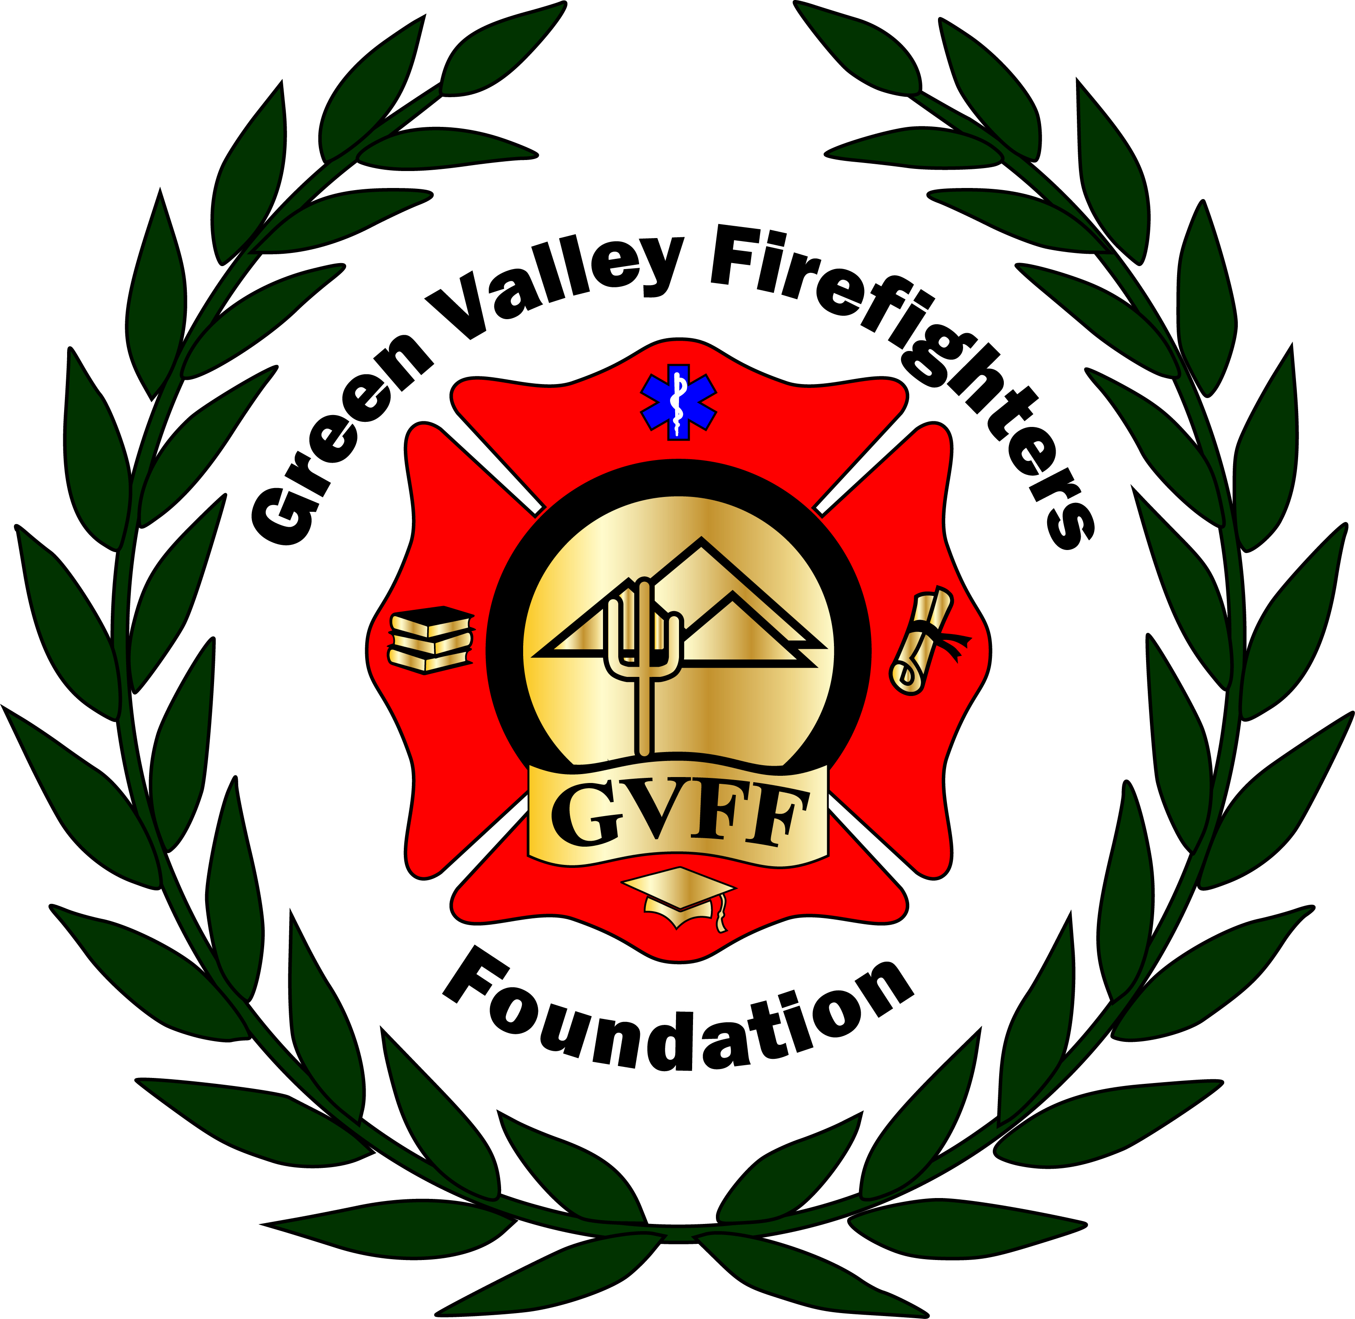
Green Valley Firefighters Foundation
1285 West Camino Encanto
Green Valley, Arizona 85622-8222
520/625.9400

NOTICE OF MEETING OF
THE GREEN VALLEY FIREFIGHTERS FOUNDATION BOARD
November 27, 2017, 5:00 P.M.
1285 W. Camino Encanto

AGENDA
- Call to Order – President Anthony Taylor
- Approval of Minutes from November 27, 2017 Meeting – Secretary Talia Carey
- Financial Report if available – Chief Chuck Wunder
- Old Business – None
- New Business – Open Group Discussion

- Pickleball
- Logistics
- Website- Registration update, what are the numbers at right now?
- Sponsorship – any new sponsors? L&T & Safeway confirmed. Will get Anthony logos.
- Open Discussion
- Assignments

- 2018 Firefighters Ball
- Epi Transition- Replacement is Miguel at QC
- Contract Update for Photo Booth- signed, locked in for next year @ $749.00 + Tax- Reduced from original quote of 1000.00 + Tax.
- Photo Booth Sponsorship Filled & Paid- Plus they bought the rest of a Table.
- Sponsorship Updates- Lovitt and Touche have filled a FF Slot @ $1500.00/Safeway Grant came back from $1500.00/ Frys grant was denied/ Talia has also reached out to UCHC, Jim Click, The Marshall Foundation, Gadabout, AFLAC, Canoa Ranch & Freeport McMoran for sponsorships, as well as Gadabout & Wyndham for Prizes/Giveaways. Chris has submitted to Desert Diamond and Geico for Sponsorships.
- Open Discussion
- Assignments follow-up

- Set Next Meeting Date – Group Discussion

- Adjourn-

