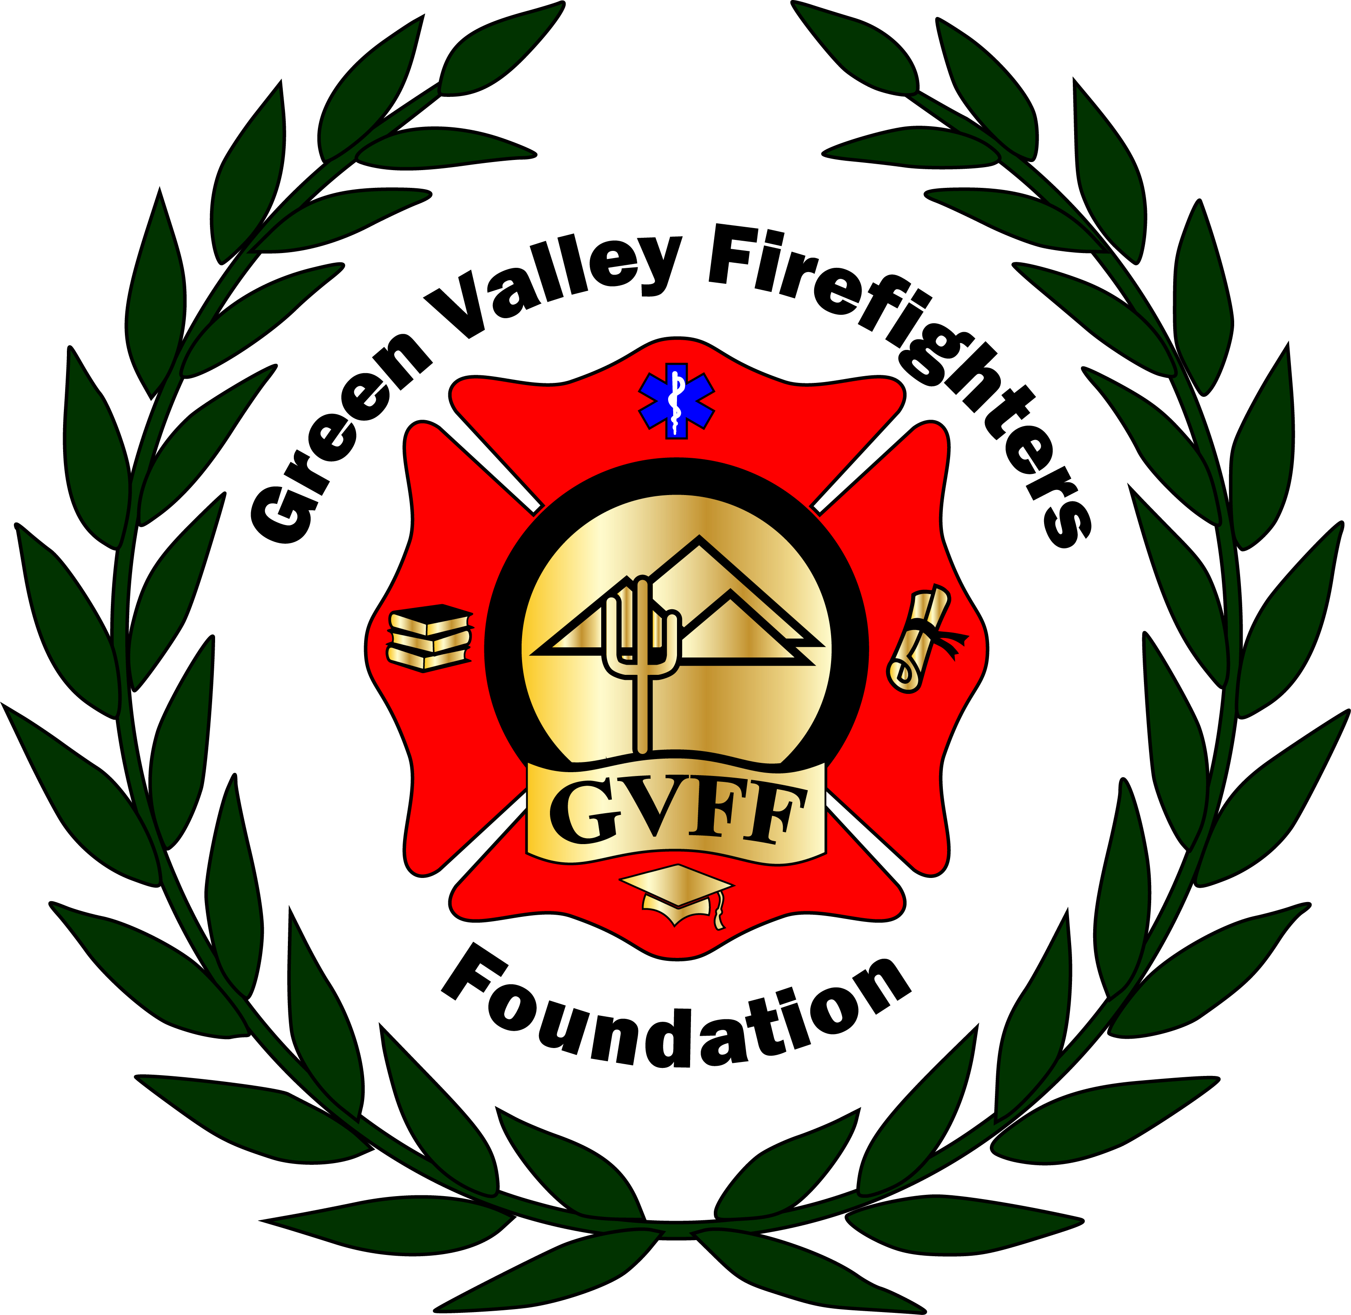
Green Valley Firefighters Foundation
1285 West Camino Encanto
Green Valley, Arizona 85622-8222
520/625.9400

NOTICE OF MEETING OF
THE GREEN VALLEY FIREFIGHTERS FOUNDATION BOARD
December 13, 2018 4:30 P.M.
GVFD HQ/1285 W. Camino Encanto

AGENDA
- Call to Order –President Anthony Taylor 4:38 p.m.
- Minute Notes from Dec 13, 2018 – Secretary Talia Carey (In draft form- Talia will go over notes as refresher)
- Financial Report – Chief Wunder – no Changes,
- Director Round Table Update – Board of Directors – No changes on t shirts (Chris). Letter update to sponsors. Caterer no showed. Kristi and Chief got quotes for Tent, lots of things. HOA meeting at the springs on the 19th.
- Old Business – None
- New Business –
- Discussion and Possible Action re: Scholarship Applications- We have received one more application for last fiscal quarter- M. Johnson- Medic.. TJ was reimbursed. Chuck motioned to table. Chris seconded. All in favor.
- Open Discussion and Possible Action re: April, 13,14 2019 Pickleball Tournament- GVFF (Anthony not here- gave date over text).
- Open Discussion and Possible action re: March 30, 2019 Mardi Gras Masquerade- GVFF – Open Table Sales- 8 Tops. Mardi Gras Under the Stars name of the event. Starts at 5:30, dinner at 6. Live band til 8. DJ starts 8-12. Band at 1200. DJ full sounds approx. 1200. Talia made motion for music up to 2500. Sarah seconded. All were in favor. Chuck motioned Authorize not to exceed $250.00 for marketing.. Chris seconded. All were in favor.
        - Music- Seth & Brittany
        - Kristi, Brittany, Chuck- Venue-Catering, Decorations
        - Websites/Ticket Sales
        - Kristi
        - Sponsorships- Sarah & Selina

- Set Next Meeting Date – January 21, 5:00P.m

- Adjourn- 5:46PM

